TASK 24 – UI FOR VIDEO

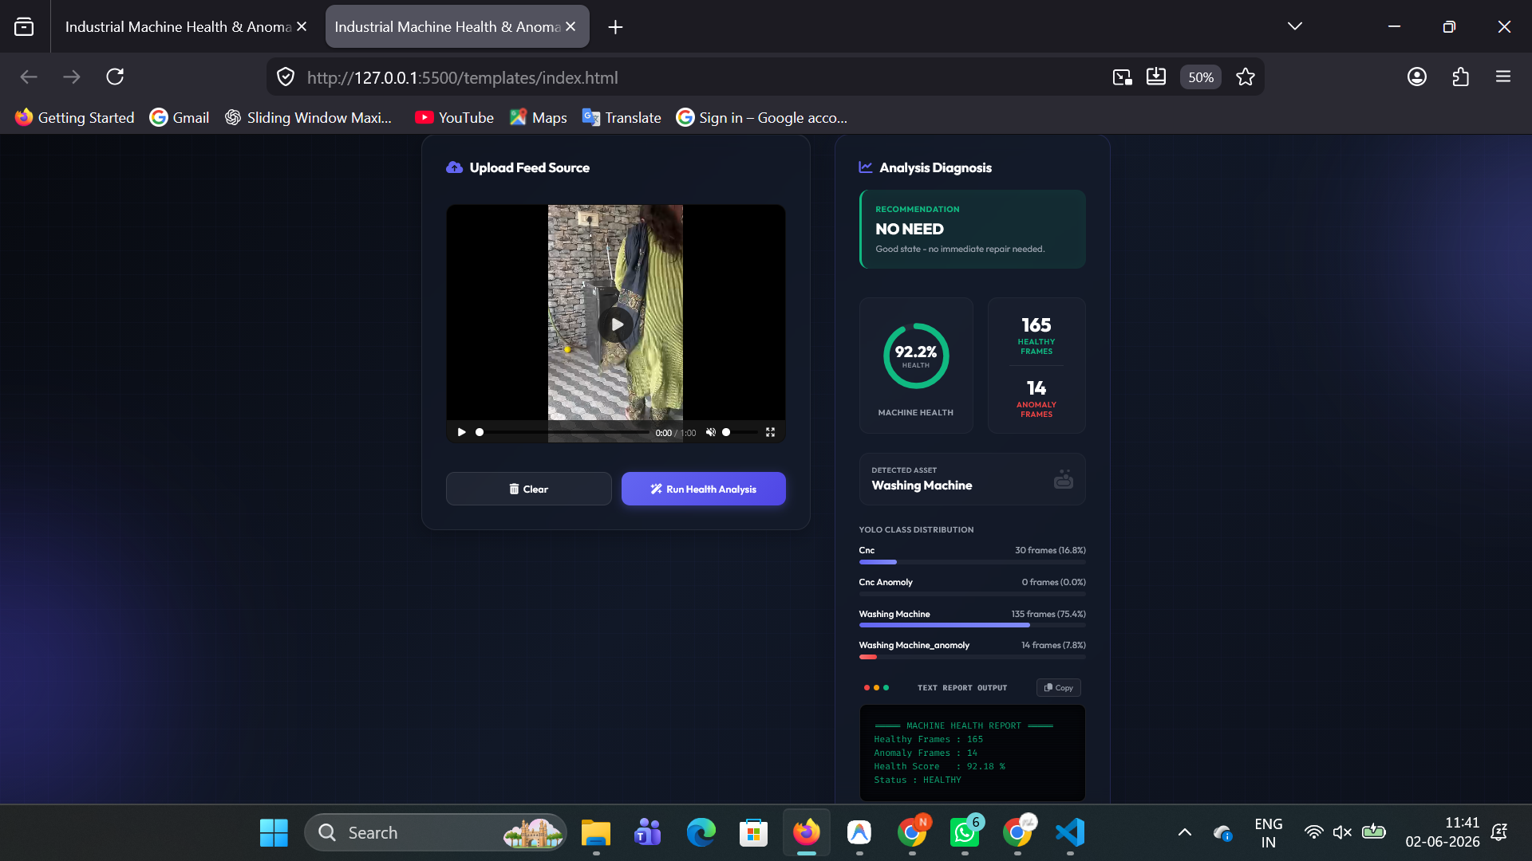
PREDICTION : Healthy

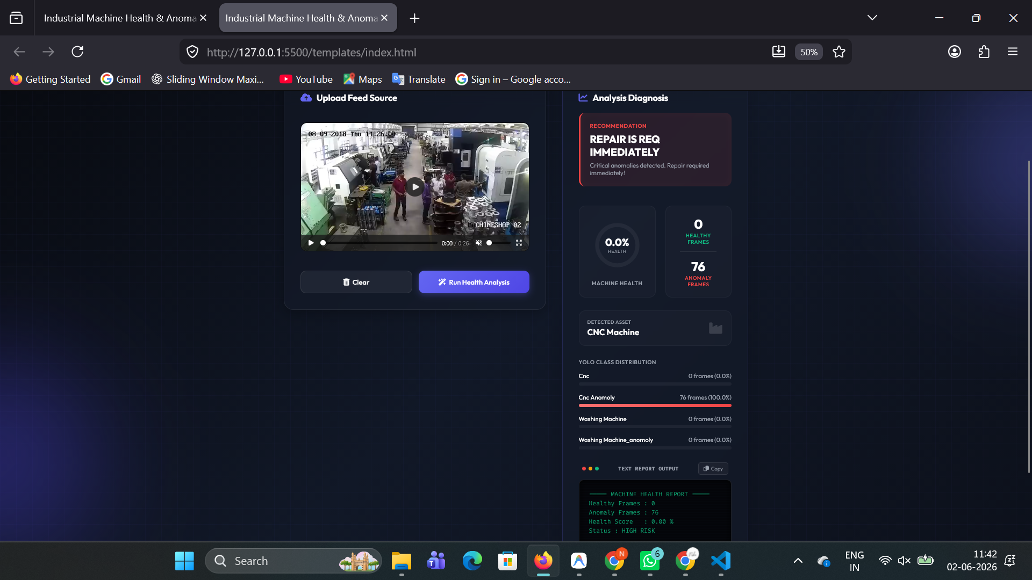
PREDICTION : High Risk

